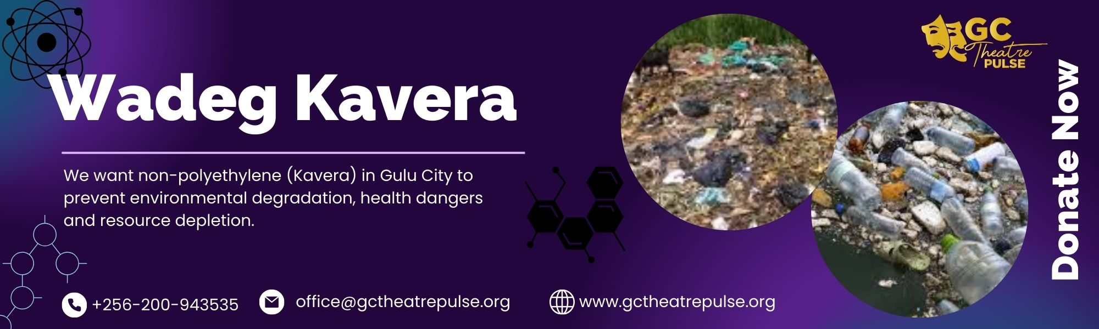

Fight Polyethylene;

WADEG KAVERA project's overall objective is to sensitize the Gulu City communities on the dangers of polyethylene (kavera) to the users, the environment, and resources. Gulu city council has four dumping sites as a way of trying to manage waste in the city however, during the rainy season dirty water flows from the waste into the communities around the dumping sites contaminating the air and bringing about the possibility of cholera outbreak in these areas and one of the major causes of this is surely the polyethylene (Kavera) and plastic bottles which don’t decay. However, many plastic bottles are being collected by Taka Taka, and some individuals collect them for sale to the concerned companies for recycling, many plastic bottles and polythene (kavera) still float on the swamps and get buried in the soil and releasing toxic chemicals to the soil which is causing soil degradation and depletion because of reckless dumping by the citizen and this is the leading cause of poverty in Gulu City and northern Uganda at large.
This project aims to advocate for the elimination of polyethylene in Gulu City and bring an end to reckless dumping.

GC Theatre Pulse programs will reach out to the different communities within Gulu City to advocate for WADEG KAVERA. The related activities are linked to the work plans under the Play/Drama and Social and Behavior Change Communication (SBCC). This project will advocate for protecting the wetland and upland soil from the harmful chemicals released into the soil by polyethylene (kavera) and plastics due to reckless dumping.

WADEG KAVERA project component includes activities structured in two work-streams:
- Mobilizing the communities to a suitable venue:
  - Using a mobilization van
  - P. A system, Lights, and stage
  - Talk shows and Radio announcements
- Performing the thematic Play/Drama and SBCC session:
  - Presenting play/Drama on WADEG KAVERA
  - Carrying out SBCC Session
  - Live interaction of community members and partner organization
- Exhibition and partner service tents
- Exhibiting non polyethylene (Kavera) products
- Partner tents for live interaction with the communities
- Developing and producing educative posters/banners
- Placing them in the strategic points in the city

The WADEG KAVERA activities will be implemented at the parish level, GC Theatre Pulse will work with the Local Councils I and III to ensure that the project has an impact on the beneficiary communities.

The project is related to the expected accomplishment (b) “Implementation of the community environmental commitments” of Project 1. WADEG KAVERA. Strategic Framework for the Gulu City Communities 1(one) year project commencing 2024 and ending 2025 and project continuity will be factored by impact and resource availability. Its successful implementation shall contribute to several Sustainable Development Goals – e.g. Goal 3 ‘Ensure healthy lives and promote well-being for all at all ages’, target ‘By 2030, substantially reduce the number of deaths and illnesses from hazardous chemicals and air, water, and soil pollution and contamination’, Goal 6 ‘Ensure access to water and sanitation for all’, target ‘By 2020, protect and restore water-related ecosystems, including forest cover, wetlands, or Goal 13 ‘Take urgent action to combat climate change and its impacts’, target ‘Integrate climate change measures into national policies, strategies and planning’. The contribution to the SDGs should be achieved through support to the establishment of the WADEA KAVERA project in the beneficiary communities as a tool for mainstreaming the key environmental and health issues.

Project beneficiary communities (i.e. 1). Gulu main market, 2). Cuk a lot, 3). Cuk Walbong, 4). Cuk pa Cenejere, 5). Cuk Pa Atuku, 6). Cuk Lacoo, 7). Cuk Layibi, 8). Cuk Ott Yat, 9). Kabedopong, 10). Oliyilong to start with).

This project will target all the Gulu citizens including the local authorities ranging from environment, health, and economic sectors/departments, Agro-production organizations, to climate change partners.

This project will seek to partner with relevant organizations, Government agencies, and well-wishers for professional advisory and consultancy services to achieve standards in activities.

Expected accomplishments
Expected accomplishments of GC Theatre Pulse activities within the WADEG KAVERA project can be summarized as follows:
- Citizens are sensitized to the dangers of using polyethylene (Kavera).
- Opportunities for community participation in the fight against environmental degradation.
- Exhibition of the non-Polyethylene (Kavera)
- Produce environmental degradation Documentaries, Films, and Plays/Drama
- Informative banner placements in strategic places in Gulu city

Indicators of achievement
The following indicators shall be formulated to determine the extent of achieving expected accomplishments:
- Reviewing the frameworks and practical implementation of WADEG KAVERA:
  - Number of partners including sponsors and donors incorporated into the project
  - Public premiere, launch, and live stage performance of the advocacy videos and audio.
  - Report and SBCC tool prepared and disseminated.
- Capacity building/Training on how to make non-polyethylene (Kavera) products
  - Number of trainees capacitated to a required level.
  - Number of communities reached and how they are adopting.

Assumptions and Risks
The environmental project beneficiaries are the Gulu city communities. It is assumed that the city council will support the WADEG KAVERA project strategic framework for the communities in Gulu City 2024– 2025. We expect a partnership with a reliable environmental/climate change partner organization and a well-wisher to support us in implementing the project successfully.

By working with environmental policymakers and engaging the politicians and local authorities i.e. high-level officials, members of the parliament, and Local Council 1(one) we shall reduce the risk of the project being sabotaged.

WADEG KAVERA Project Budget
An estimated budget of USD 15,000 is required for the successful implementation of this project. The budget will cover awareness campaigns, developing and dissemination of the educational materials, Transportation, capacity building activities, monitoring and evaluation, and project management costs. Additional resources, such as partnerships with local organizations and in-kind contributions, donation will be sought to maximize project outcomes.

In conclusion.
Environment/Climate Change is a fundamental aspect of, poverty, gender equality, and health. Therefore, by implementing the WADEG KAVERA project, we can solve the problem of environmental degradation, poverty, and health. We seek support and collaboration from sponsors, donors, partners, and well-wisher to successfully accomplish the goal and objective.

